Mini Project Report on

“Synaptic - Adaptive Learning Platform”



Submitted By:
Charan Teja S (U25UV23T006016)
Sanjay V Guladakoppa (U25UV23T006047)
Sujeth A S (U25UV23T006052)
6th Sem, B. Tech (AIML)

Under the Guidance of
Dr. Champa H N
Professor
Department of Computer Science and Engineering
UVCE

DEPARTMENT OF COMPUTER SCIENCE AND ENGINEERING

UNIVERSITY OF VISVESVARAYA COLLEGE OF ENGINEERING
(First State Autonomous University on IIT Model)
K.R. Circle, Bangalore-560001

April - 2026

University Of Visvesvaraya College of Engineering
(First State Autonomous University on IIT Model)
K.R. Circle, Bangalore-560001

Department of Computer Science and Engineering

CERTIFICATE

This is to certify that Mr. Sanjay V Guladakoppa (U25UV23T006047), 6th Sem, B. Tech (AIML), has successfully completed Mini-Project work entitled “Synaptic - Adaptive Learning Platform”, prescribed by the University of Visvesvaraya College of Engineering for the academic year 2026.

Dr. Champa H N Dr. S H Manjula
Professor, Chairperson & Professor
Department Of CSE, Department Of CSE,
UVCE, Bengaluru UVCE, Bengaluru

……………………………… ……………………………
Examiner 1 Examiner 2

ACKNOWLEDGEMENT

We are deeply grateful to the University of Visvesvaraya College of Engineering for providing us with the opportunity and resources to undertake this project.
We would like to thank Dr. Subhashish Tripathy, Director, UVCE, for providing us with all the facilities to work on this project. I am indebted to him for being my pillar of strength and inspiration.
We are thankful to Dr. S H Manjula, Chairperson, Department of Computer Science and Engineering, for her co-operation and encouragement at all stages of our work.
We sincerely express our gratitude to our professor, Dr. Champa H N, Professor, Department of CSE, UVCE, for her invaluable guidance, encouragement, and constant support throughout this project, expertise and constructive feedback greatly contributed to the successful completion of project.
We also extend our sincere thanks to our parents, non-teaching staff, well-wishers, and dear classmates for their support, encouragement, and kind cooperation.

Charan Teja S (U25UV23T006016)
Sanjay V Guladakoppa (U25UV23T006047)
Sujeth A S (U25UV23T006052)

ABSTRACT
The rapid advancement of digital education and Artificial Intelligence has created a strong need for intelligent and adaptive learning systems that can cater to individual learner needs. Traditional e-learning platforms primarily rely on static content delivery models, where the same material is presented to all learners regardless of their prior knowledge, learning pace, or cognitive abilities.
Human learning is inherently dynamic and non-linear. It involves repeated cycles of attempting a concept, receiving feedback, reinforcing knowledge, forgetting over time, and recalling information to strengthen memory. Conventional systems fail to incorporate these cognitive principles, resulting in shallow understanding and weak long-term retention.
To address these limitations, this project presents Synaptic - an Adaptive Learning Platform, designed to model the complete learning lifecycle using computational techniques inspired by cognitive science. The system integrates three key components: Bayesian Knowledge Tracing (BKT) for estimating the learner’s knowledge state, SM-2 Spaced Repetition Algorithm for optimizing review scheduling based on memory decay, and a Directed Acyclic Graph (DAG) to enforce prerequisite relationships among topics.
The platform follows a structured input → process → output model, where user interactions such as answering questions and navigating content are continuously analysed. Based on this analysis, the system dynamically selects appropriate learning material, schedules revisions, and updates the learner’s knowledge state. The content is organized using structured JSON-based files, enabling modular and scalable content delivery.
To evaluate the effectiveness of the system, a behavioural simulation was conducted involving multiple learners and learning strategies. The results indicate that the adaptive approach significantly improves learning gain, retention, and mastery stability compared to traditional sequential learning systems.
The Synaptic platform demonstrates how integrating cognitive science principles with adaptive algorithms can lead to more efficient and personalized learning experiences, making it a promising solution for modern education systems.
TABLE OF CONTENTS

Title Page No.
- Introduction 04
- Literature Review 06
- Hardware & Software Requirements 08
- Proposed System Design 10
- Implementation 17
- Results 21
- Conclusion & Future Enhancements 27
- Bibliography 28

INTRODUCTION
1.1 Introduction
The integration of technology in education has revolutionized how knowledge is delivered and consumed. Online learning platforms have enabled learners to access content anytime and anywhere. Despite these advancements, most systems fail to provide effective learning experiences because they do not align with human cognitive processes.
Human learning is inherently iterative and dynamic. It involves repeated exposure, feedback, reinforcement, and recall. Traditional platforms ignore these aspects and follow a linear approach, where content is presented in a fixed sequence without considering learner performance.
This mismatch between system design and human cognition results in poor engagement, weak understanding, and rapid forgetting of learned material.
1.2 Problem Statement
Existing learning platforms face several key challenges:
- Lack of structured learning paths: Many online resources are scattered and do not follow a logical progression.
- Low engagement: Traditional platforms rely heavily on passive content consumption.
- Absence of real-time feedback: Learners do not receive immediate insights into their performance.
- Difficulty in tracking progress: Users often lose motivation due to lack of measurable outcomes.

This project aims to solve these problems by providing:
- A phase-wise structured curriculum
- Interactive quizzes for active learning
- Instant feedback mechanisms
- Progress tracking and streak systems for motivation
1.3 Objectives
The main objectives of this project are:
- To design an adaptive learning platform
- To model human learning using computational techniques
- To implement BKT, SM-2, and DAG algorithms
- To simulate learner behavior and evaluate performance

LITERATURE REVIEW

The field of adaptive learning has evolved significantly with the integration of machine learning and cognitive science principles. Various research works have attempted to model learner behavior, improve retention, and personalize content delivery. This section reviews key contributions and identifies limitations that motivated the development of the Synaptic system.
One of the foundational works in adaptive learning is Knowledge Tracing, introduced by Corbett and Anderson [2]. Their model, known as Bayesian Knowledge Tracing (BKT), estimates a learner’s knowledge state using probabilistic methods. It considers parameters such as learning rate, guess probability, and slip probability to update mastery levels. While BKT is effective in tracking learning progress, it primarily focuses on knowledge estimation and does not address memory retention or revision scheduling.
To improve memory retention, Wozniak [1] introduced the SM-2 algorithm, which forms the basis of spaced repetition systems. This algorithm dynamically schedules review intervals based on learner performance, ensuring that concepts are revised just before they are forgotten. Pavlik and Anderson [6] further extended this concept by modeling the spacing effect using cognitive principles. However, these approaches focus only on memory and do not integrate knowledge progression or prerequisite structures.
Recent advancements in machine learning have explored deeper models such as Deep Knowledge Tracing (DKT) by Piech et al. [7], which uses neural networks to predict student performance. Although DKT improves prediction accuracy, it lacks interpretability and does not explicitly model cognitive processes like forgetting and reinforcement.
In the domain of personalized learning, Latif [3] and Shahzad [4] explored the use of machine learning and multi-agent systems for analyzing student performance and adapting content. These systems consider behavioral data but often lack a structured representation of knowledge dependencies. Similarly, Essa et al. [5] provided a comprehensive review of adaptive learning technologies, highlighting the importance of personalization but also noting that many systems fail to integrate multiple cognitive aspects into a unified framework.
A key limitation observed across these studies is that most systems address only a subset of the learning process. Some focus on knowledge estimation, others on memory retention, and some on personalization, but very few integrate all these aspects together. Additionally, many systems do not enforce structured learning paths, allowing learners to skip prerequisites, which negatively impacts understanding.
The Synaptic Adaptive Learning Platform addresses these limitations by combining multiple approaches into a single system. It integrates Bayesian Knowledge Tracing [2] for estimating learner knowledge, SM-2 spaced repetition [1] for optimizing memory retention, and Directed Acyclic Graphs (DAGs) to enforce prerequisite relationships between topics. Unlike previous systems, Synaptic models the complete learning lifecycle, including learning, forgetting, reinforcement, and progression.
Furthermore, the system introduces an adaptive engine that dynamically selects content based on learner performance, ensuring both personalization and structure. By addressing the gaps identified in existing research, the proposed system provides a more comprehensive and cognitively aligned learning solution.

HARDWARE AND SOFTWARE REQUIREMENTS

To successfully implement and run this project, a combination of software tools and hardware resources are required. The following requirements ensure smooth functioning of the system.

3.1 Hardware Requirements
The Synaptic AI Learning Platform is designed to operate efficiently on standard computing systems without requiring high-end hardware. This ensures accessibility for a wide range of users, including students and beginners.
The hardware requirements for the system are as follows:
- Processor: Intel Core i3 or equivalent (Intel i5 or higher recommended for better performance)
- RAM: Minimum 4 GB (8 GB recommended for smooth multitasking)
- Storage: At least 10 GB of free disk space
- Display: Standard monitor with a resolution of 1366 × 768 or higher
- Input Devices: Keyboard and mouse or touchpad
- Internet Connectivity: Stable broadband internet connection for accessing the web application
These specifications are sufficient to ensure that the platform runs smoothly, supports interactive features, and provides a seamless user experience.

3.2 Software Requirements
The development and execution of the Synaptic platform rely on modern software technologies and tools. These components are selected to ensure scalability, performance, and ease of development.
The software requirements are categorized as follows:
Operating System
- Windows 10/11
- Linux (Ubuntu or similar distributions)
- macOS
Frontend Technologies
- React.js: Used for building dynamic and responsive user interfaces
- HTML5: For structuring web pages
- CSS3 / Tailwind CSS: For styling and layout design
- JavaScript: For implementing interactive functionality

Backend Technologies
- Node.js / Django: For handling server-side logic and application processing
- REST APIs: For communication between frontend and backend

Database
- Currently, structured JSON files are used for managing content. A relational database such as SQLite is proposed for future implementation.

Development Tools
- Visual Studio Code (Code Editor)
- Git (Version Control System)
- Postman (API testing tool)

Web Browsers
- Google Chrome
- Microsoft Edge
- Mozilla Firefox

PROPOSED SYSTEM DESIGN

4.1 Overview of Proposed System
The proposed system, Synaptic, is an adaptive learning platform designed to address the limitations of traditional systems. It integrates cognitive science principles with computational models to provide a personalized learning experience.
The system operates using a dynamic approach where content delivery is continuously adjusted based on the learner’s performance. It uses Bayesian Knowledge Tracing to estimate the learner’s knowledge state, allowing the system to identify strengths and weaknesses.
To address the issue of memory decay, the system incorporates the SM-2 spaced repetition algorithm. This ensures that learners review concepts at optimal intervals, improving long-term retention.
The system also uses a Directed Acyclic Graph to enforce prerequisite relationships between topics. This prevents learners from skipping foundational concepts and ensures a structured learning path.
In addition to these core components, the system includes a simulation engine that models learner behaviour and evaluates different learning strategies. This allows the system to analyse performance and optimize learning outcomes.
The proposed system represents a significant improvement over traditional systems by providing a comprehensive and adaptive learning experience.
4.2 Cognitive Foundations of Learning
The design of the Synaptic platform is heavily influenced by cognitive science principles that describe how humans learn. Understanding these principles is essential for building an effective learning system.
Human learning is not a linear process but a cyclical one. It involves multiple stages, including attempt, feedback, reinforcement, forgetting, and recall. When a learner encounters new information, they attempt to understand it and apply it. Feedback helps them identify whether their understanding is correct or incorrect. Correct understanding is reinforced, while incorrect understanding is corrected.
Over time, however, memory begins to decay. This phenomenon is described by the forgetting curve, which shows that information is lost exponentially if it is not revisited. This highlights the importance of revision and reinforcement in learning.
Another critical concept is active recall. Unlike passive learning methods such as reading or watching videos, active recall requires the learner to retrieve information from memory. This process strengthens neural connections and improves retention.
Learning is also inherently hierarchical. Complex concepts are built upon simpler ones. For example, understanding advanced algorithms requires knowledge of basic programming constructs. If foundational concepts are not mastered, learners may struggle with advanced topics.
The Synaptic system incorporates these principles by ensuring that learners engage in active recall, receive continuous feedback, and revisit content at optimal intervals. The use of DAG ensures that learning follows a structured path, while SM-2 ensures that revision is scheduled effectively.

4.3 System Components
The Synaptic platform is composed of several interconnected components that work together to provide an adaptive learning experience.
The first component is the content system, which stores educational material in structured JSON files. These files include questions, answers, explanations, and metadata for each skill. This modular structure allows the system to easily manage and update content.
The second component is the adaptive engine, which is the core of the system. This engine processes user interactions and applies algorithms to determine the next best action. It continuously updates the learner’s knowledge state and selects appropriate content.
The third component is the skill graph, which represents the relationships between different concepts. This graph is implemented as a Directed Acyclic Graph, where nodes represent skills and edges represent prerequisite relationships. The graph ensures that learners follow a logical progression and do not skip essential concepts.
Another important component is the simulation engine, which is used to evaluate the system. It simulates multiple learners and tracks their performance across different strategies. This allows the system to analyse its effectiveness and identify areas for improvement.

4.4 Algorithms Used
1. Bayesian Knowledge Tracing (BKT)
Bayesian Knowledge Tracing is a probabilistic model used to estimate the learner’s knowledge state. In this model, each skill is associated with a probability that represents the likelihood that the learner has mastered it.
The model is based on four key parameters: initial knowledge, learning rate, guess probability, and slip probability. The initial knowledge represents the learner’s starting level. The learning rate determines how quickly the learner acquires new knowledge. The guess probability accounts for the possibility that a learner may answer correctly without fully understanding the concept, while the slip probability accounts for mistakes made despite understanding.
When a learner answers a question, the system updates the probability of mastery using Bayesian inference. If the answer is correct, the probability increases. If the answer is incorrect, the probability decreases. Over time, this allows the system to accurately track the learner’s knowledge state.
BKT is particularly effective because it models uncertainty. Instead of assuming that a learner either knows or does not know a concept, it represents knowledge as a probability, allowing for more nuanced decisions.
2. SM-2 Algorithm
The SM-2 algorithm is used to optimize memory retention through spaced repetition. It schedules reviews at intervals that maximize retention while minimizing effort.
The algorithm assigns an ease factor to each concept, which represents how easy it is for the learner to remember. Based on the learner’s performance, the algorithm adjusts the interval between reviews. If the learner performs well, the interval increases, reducing the frequency of reviews. If the learner struggles, the interval decreases, ensuring more frequent revision.
This approach ensures that concepts are reviewed just before they are likely to be forgotten. By doing so, the system reinforces memory and improves long-term retention.
The SM-2 algorithm is particularly effective because it adapts to the learner’s performance. It does not use fixed intervals but adjusts dynamically, making it more efficient than traditional revision methods.

4.5 System Architecture
The Synaptic platform follows a layered architecture designed to enable intelligent and adaptive learning.
Input Layer:
Captures learner interactions such as quiz responses, navigation behavior, and session activity. This data acts as the foundation for personalization.
Processing Layer:
Validates and pre-processes incoming data to ensure accuracy and consistency before analysis.
Adaptive Engine (Core Layer):
The central intelligence of the system. It applies algorithms like Bayesian Knowledge Tracing (BKT) and SM-2 spaced repetition to continuously update the learner’s knowledge state. It also interacts with the skill graph to unlock or recommend the next best learning step.
Output Layer:
Delivers personalized learning experiences, including adaptive questions, feedback, progress insights, and recommendations.
Data Layer:
Maintains learner data in a structured database and stores learning content such as questions, explanations, and skill graphs.
Overall, the architecture is modular and scalable, allowing seamless enhancements, efficient performance, and future integration with advanced systems, as illustrated in Fig. 4.5.1

4.6 Module Design
The system is divided into multiple modules, each handling a specific functionality.
1. User Authentication Module
- User authentication is part of the proposed system design and is not fully implemented in the current version
- Ensures secure access to user-specific data
- Maintains session management
2. Dashboard Module
- Displays an overview of user progress
- Shows:
  - Skills mastered
  - Active learning topics
  - Pending reviews
- Provides quick navigation to learning modules
This module helps users stay informed about their learning journey.
3. Learning Module
- Organized into phases and topics
- Each phase represents a level of learning:
- Provides structured content for each topic
- Tracks completion status
This module ensures a logical progression of knowledge.
4. Quiz and Evaluation Module
- Presents multiple-choice questions after each topic
- Evaluation is handled at the frontend level using predefined JSON-based question sets
- Displays:
  - Correct answers
  - Incorrect responses
This module reinforces learning through active recall and feedback.
5. Progress Tracking Module
- The system is designed to support user performance tracking; in the current version, progression is managed at the interface level
- Updates completion percentage
- Maintains learning streaks
- Displays progress visually on dashboard
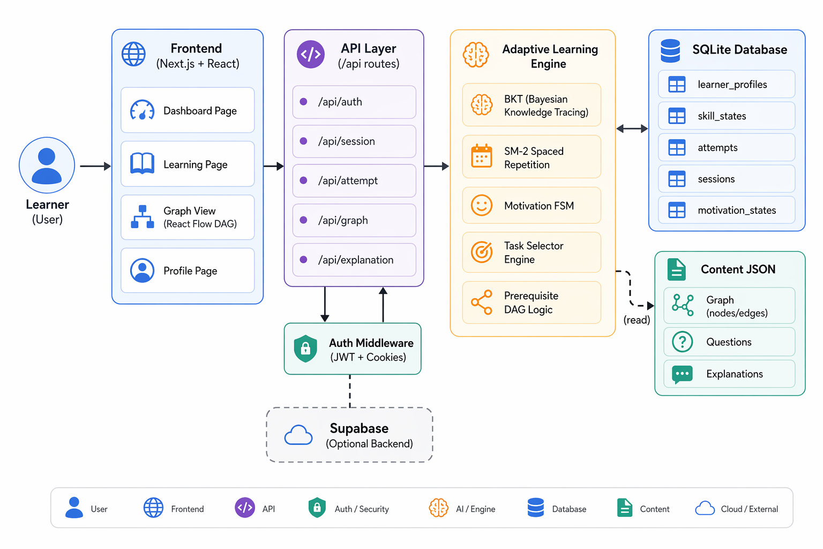

Fig 4.5.1 System Architecture

IMPLEMENTATION

The implementation of the Synaptic - Adaptive Learning Platform is divided into two main parts: Frontend Implementation and Backend Implementation. Each part is responsible for specific functionalities that together ensure smooth system operation.

5.1 System Development
The implementation of the Synaptic adaptive learning platform is carried out using a modern full-stack web development approach. The system is designed to be modular, scalable, and efficient, ensuring that it can handle dynamic learning behavior while maintaining performance.
The frontend of the system is developed using Next.js, which provides a powerful framework for building responsive and interactive user interfaces. Next.js allows for both server-side rendering and client-side rendering, ensuring fast loading times and smooth user experiences. The interface is designed to be intuitive, allowing users to easily navigate through learning sessions, view progress, and interact with content.
TypeScript is used in the development process to ensure type safety and improve code reliability. By enforcing strict typing, TypeScript helps in reducing runtime errors and makes the codebase easier to maintain. Tailwind CSS is used for styling the application, enabling the creation of clean and responsive designs with minimal effort.
The backend of the system is implemented using Next.js API routes, which handle all server-side logic. These API routes process user requests, manage authentication, and execute the adaptive learning algorithms. This approach eliminates the need for a separate backend framework, simplifying the overall architecture.
The system uses SQLite as the database for storing user data, learning progress, and system logs. SQLite is used for local development due to its simplicity, while Supabase provides a scalable cloud-based solution for deployment. The database stores critical information such as user profiles, skill mastery levels, attempt history, and review schedules.
Version control is managed using GitHub, which allows for efficient collaboration and tracking of changes. Visual Studio Code is used as the primary development environment due to its extensive support for extensions and debugging tools.
5.2 Modules of the System
The Synaptic platform is divided into several modules, each responsible for a specific functionality. This modular design improves maintainability and allows for easier debugging and future enhancements.
The authentication module handles user registration, login, and session management. It ensures that only authorized users can access the system and maintains user-specific data throughout the learning process.
The adaptive learning engine is the core module of the system. It processes user interactions and applies algorithms such as Bayesian Knowledge Tracing and SM-2 to determine the learner’s knowledge state. Based on this information, it selects appropriate content and schedules reviews.
The skill graph module represents the structure of knowledge using a Directed Acyclic Graph. It manages the relationships between different skills and ensures that prerequisites are satisfied before unlocking new topics.
The session manager controls the flow of learning sessions. It tracks user progress, manages question sequences, and ensures that the learning experience remains continuous and structured.
Another important module is the simulation engine, which is used to evaluate the system. It simulates multiple learners and tracks their performance under different strategies, providing valuable insights into system effectiveness.
5.3 Database Design
The database plays a crucial role in storing and managing the data required for adaptive learning. The design of the database is structured to efficiently handle user interactions and system updates.
The user table stores basic information such as user ID, username, and authentication details. Each user is associated with a unique profile that tracks their learning progress.
The skill mastery table stores the knowledge state of each user for different skills. This includes the probability of mastery calculated using Bayesian Knowledge Tracing.
The attempts table records all user interactions, including question attempts, responses, and timestamps. This data is used to update the knowledge state and analyze learning patterns.
The review schedule table stores information related to spaced repetition. It includes the next review date, ease factor, and interval for each skill, as determined by the SM-2 algorithm.
The database is designed to support efficient queries and updates, ensuring that the system can handle real-time interactions without performance issues.
5.4 Working Flow of the System
The working of the Synaptic platform follows a structured flow that ensures a smooth and adaptive learning experience.
The process begins with user authentication, where the user logs into the system. Once authenticated, the system retrieves the user’s data, including their knowledge state and learning history.
The user then begins a learning session, where the system selects a question based on the learner’s current knowledge level. This selection is performed by the adaptive engine, which considers factors such as difficulty, prerequisites, and review schedules.
When the user answers a question, the system evaluates the response and provides immediate feedback. If the answer is correct, the system reinforces the concept. If the answer is incorrect, the system provides explanations to help the learner understand the mistake.
The knowledge state is then updated using Bayesian Knowledge Tracing, and the review schedule is updated using the SM-2 algorithm. The skill graph is also updated to unlock new topics if prerequisites are satisfied.
This process continues iteratively, allowing the system to adapt to the learner’s performance and provide a personalized learning experience, as illustrated in Fig. 5.4.1

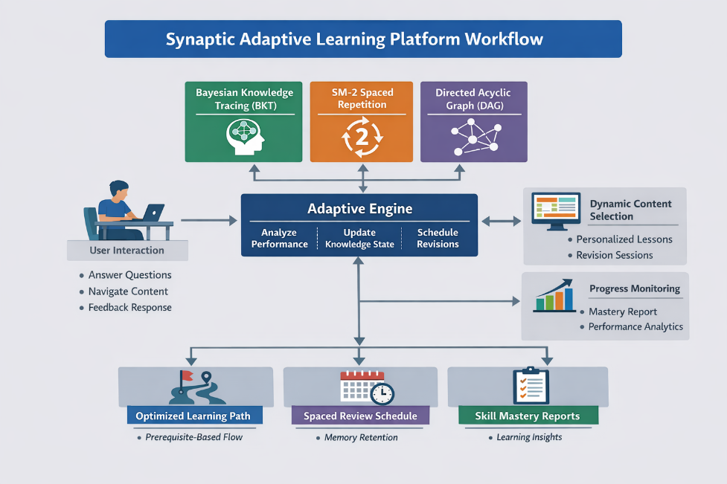
Fig 5.4.1 Working Flow of the System

RESULTS

The implementation of the Synaptic - Adaptive Learning Platform was successfully tested to evaluate its functionality, performance, and overall user experience. The results demonstrate that the system meets its objectives of providing a structured, interactive, and efficient learning environment for users.
Main Results:
- Successful Implementation of Core Features.
- Interactive Learning Experience.
- Real-Time Feedback Mechanism
- Efficient Progress Tracking
- Improved User Engagement and Motivation
- Smooth System Performance
- Scalability of the System
- User-Friendly Interface

6.1 Simulation Setup
The performance of the Synaptic platform is evaluated using a simulation-based approach. The simulation involves a set of virtual learners interacting with the system under controlled conditions.
A total of 50 users are simulated, each interacting with 10 different skills. The simulation runs for multiple steps, allowing the system to track learning progression over time. The dataset used for simulation is synthetic, generated to mimic real-world learning behaviour.
Multiple learning strategies are tested, including Random, Fixed Sequence, Weakest First, Review-Based, and Adaptive (proposed system). These strategies are compared based on various performance metrics to evaluate their effectiveness.

6.2 Learning Gain Analysis
The learning gain represents the improvement in knowledge over time. The results show that the adaptive strategy achieves the highest learning gain of 0.5799, outperforming all other strategies. This indicates that the system is effective in improving learning outcomes by personalizing content delivery. The adaptive strategy continuously adjusts to the learner’s performance, ensuring that content is neither too easy nor too difficult.
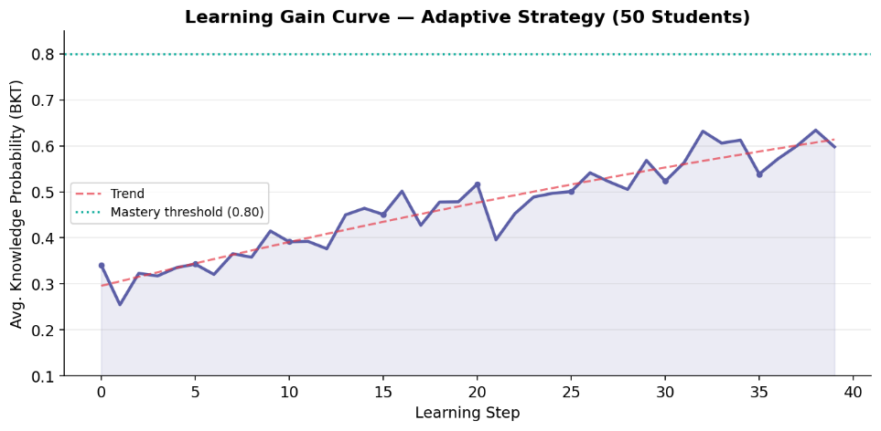
Fig 6.2.1 Learning Gain Curve
6.3 Mastery Progress Analysis
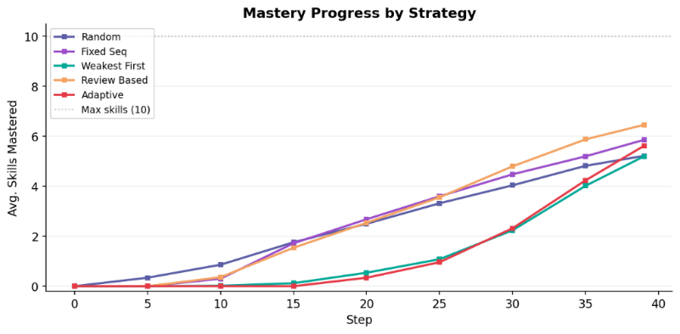
Mastery progress refers to the rate at which learners achieve mastery in different skills. The results show that the adaptive system provides a balanced progression, ensuring that learners achieve stable mastery over time. Unlike other strategies that may prioritize speed or coverage, the adaptive system focuses on maintaining a balance between the two. This results in more consistent learning outcomes.

Fig 6.3.1 Master Progress Analysis
6.4 Difficulty Balance
The difficulty balance metric measures how well the system maintains an optimal level of challenge for the learner. The results show that the adaptive system operates within the desirable difficulty range, ensuring that learners remain engaged without being overwhelmed. Maintaining the right level of difficulty is crucial for effective learning, as it encourages effort while preventing frustration.
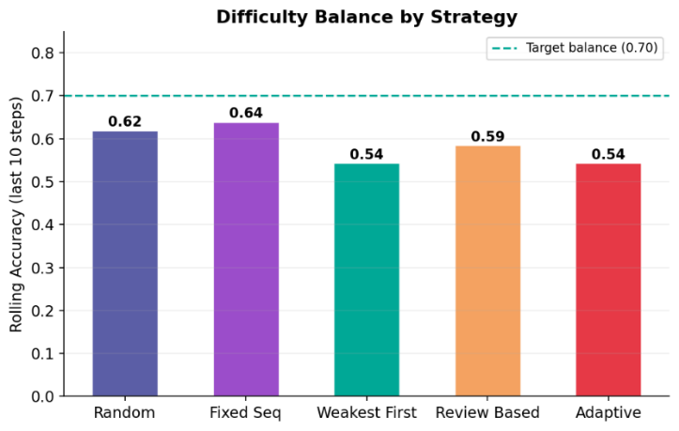
Fig 6.4.1 Difficulty Balance Graph
6.5 Review Timing Analysis
The review timing analysis evaluates how effectively the system schedules revisions. The results show that the system tends to trigger reviews early, with 96.8% of reviews occurring in the early stage. This suggests that while the system effectively reinforces learning, there is potential for improvement in optimizing review intervals. Adjusting the SM-2 parameters could lead to better spacing and improved retention.
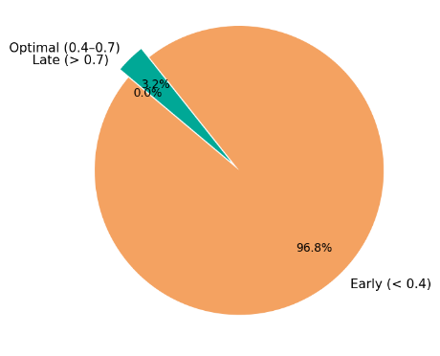
Fig 6.5.1 Review Timing Distribution

6.6 Heatmap Analysis
The heatmap provides a visual representation of skill mastery across learners. It highlights areas where learners perform well and areas where they struggle. The results show that certain skills achieve high mastery levels, while others lag behind. This indicates potential imbalances in the curriculum and highlights areas for improvement.
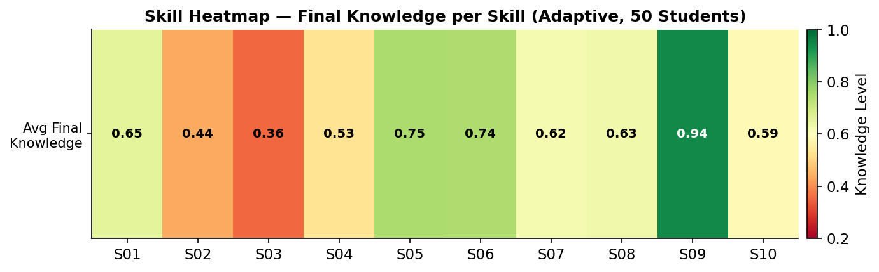
Fig 6.6.1 Skill Heatmap

6.7 Strategy Comparison Dashboard

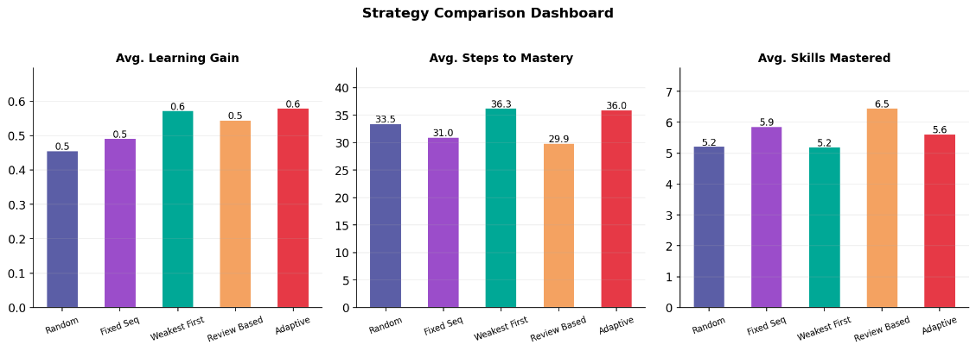
Fig 6.7.1 Strategy Comparison Dashboard

6.8 Screenshots of Frontend
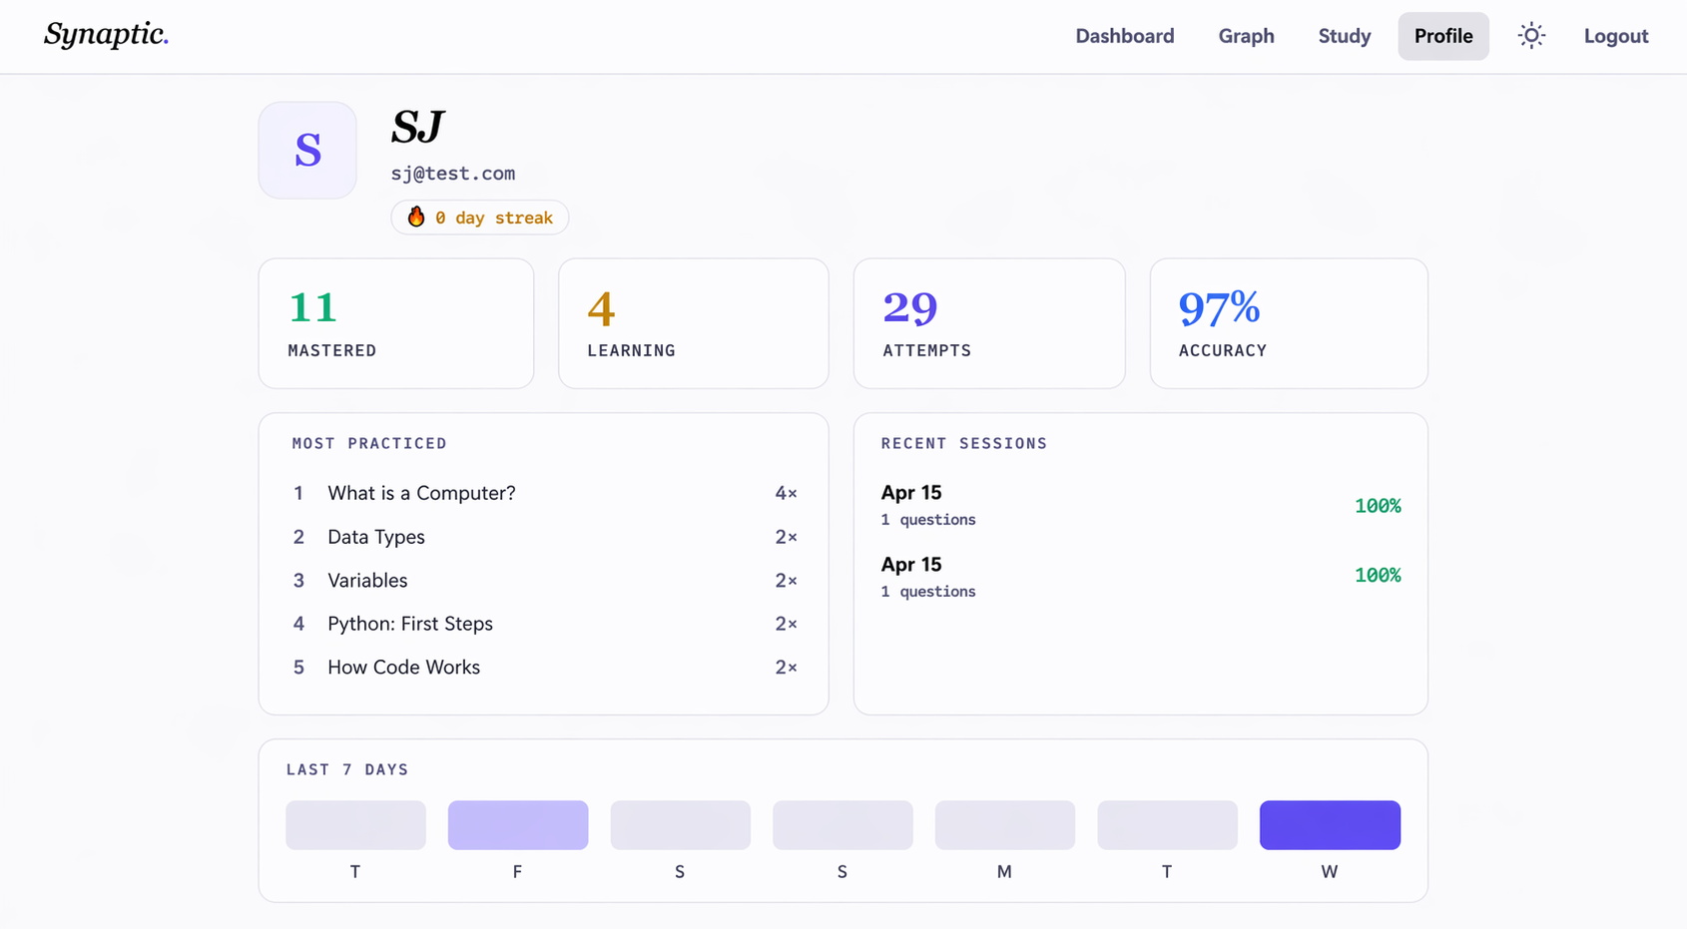
Fig 6.8.1 User Profile

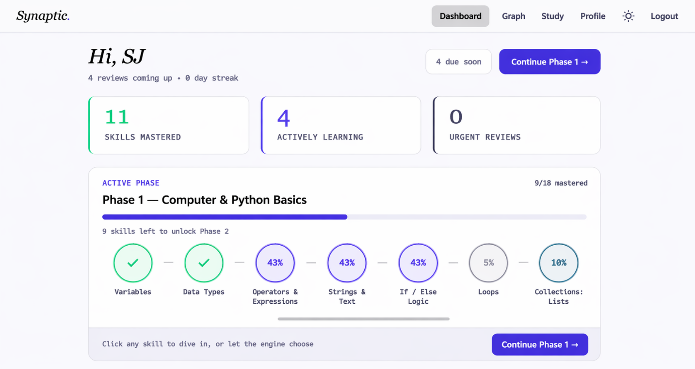

Fig 6.8.2 User Dashboard
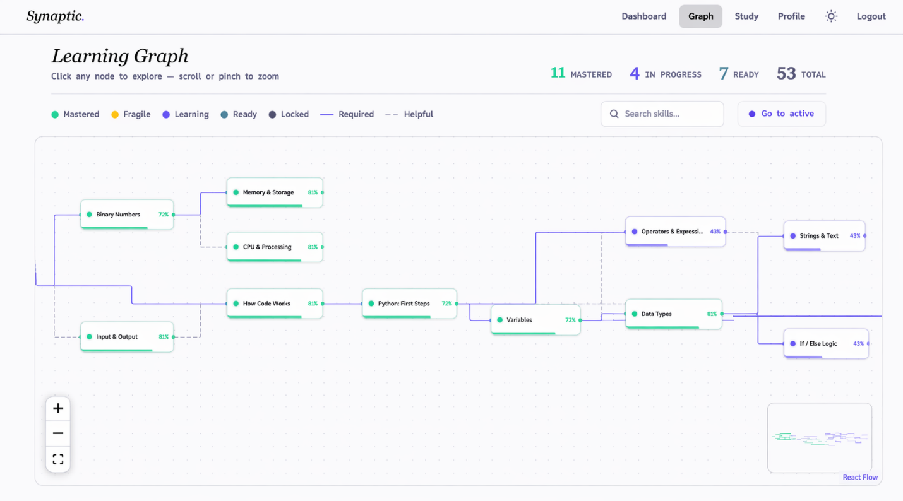
Fig 6.8.3 Learning Graph

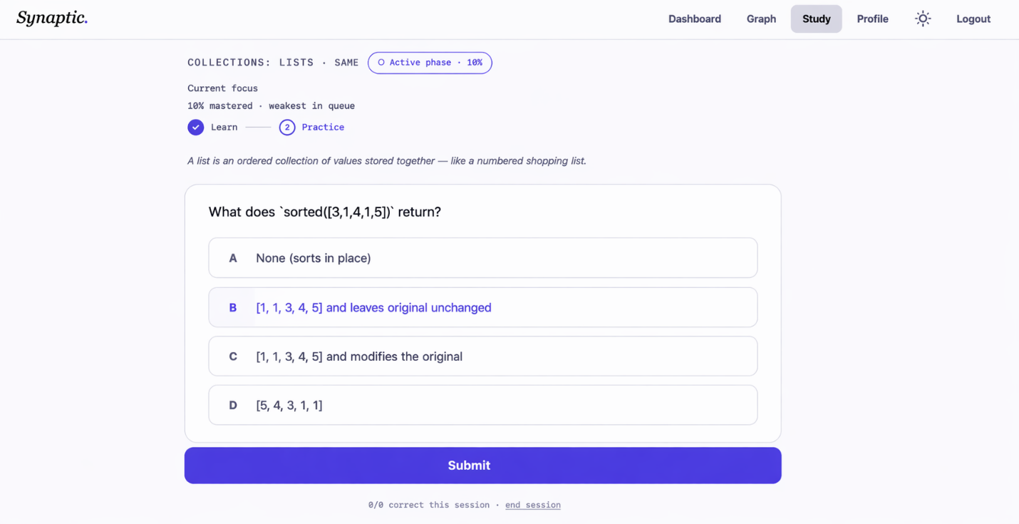
Fig 6.8.4 Learning Page

CONCLUSION AND FUTURE ENHANCEMENTS

7.1 Conclusion
The Synaptic adaptive learning platform successfully demonstrates the effectiveness of combining cognitive science principles with computational algorithms. By integrating Bayesian Knowledge Tracing, SM-2 spaced repetition, and Directed Acyclic Graphs, the system provides a personalized and structured learning experience.
The results of the simulation show that the adaptive strategy outperforms traditional approaches in terms of learning gain, retention, and mastery stability. The system effectively models human learning behavior, ensuring that learners receive the right content at the right time.
One of the key strengths of the system is its ability to continuously adapt to the learner’s performance. This ensures that the learning experience remains engaging and efficient.
7.2 Future Enhancements
- Add explanation-based answers to capture real understanding.
- Build a reasoning evaluation module (rule-based → NLP/LLM upgrade).
- Combine correctness + reasoning + behaviour as input to BKT.
- Upgrade BKT to modern knowledge tracing (e.g., DKT).
- Strengthen SM2 with adaptive scheduling based on performance patterns.
- Integrate behaviour analytics (time, retries, hesitation) for accuracy.
- Implement Bloom’s taxonomy tagging for cognitive-level control.
- Enhance adaptive engine using multi-metric scoring.
- Add practical evaluation modules (coding + real-time assessment).
- Build advanced dashboard + skill profile + personalized recommendations

BIBLIOGRAPHY

[1] P. A. Wozniak, Optimization of Learning, Master’s Thesis, Poznan University of Technology, Poznan, Poland, 1990.
[2] A. T. Corbett and J. R. Anderson, “Knowledge Tracing: Modeling the Acquisition of Procedural Knowledge,” User Modeling and User-Adapted Interaction, vol. 4, no. 4, Springer, Netherlands, 1994.
[3] G. Latif, “Machine Learning in Higher Education: Students’ Performance Assessment Considering Online Activity Logs,” IEEE Access, vol. 11, IEEE, USA, 2023.
[4] R. Shahzad, “Multi-Agent System for Students’ Cognitive Assessment in E-Learning Environment,” IEEE Access, vol. 12, IEEE, USA, 2024.
[5] S. G. Essa, T. Celik, and N. E. Human-Hendricks, “Personalized Adaptive Learning Technologies Based on Machine Learning Techniques to Identify Learning Styles: A Systematic Literature Review,” IEEE Access, IEEE, USA, 2023.
[6] P. I. Pavlik Jr. and J. R. Anderson, “Practice and Forgetting Effects on Vocabulary Memory: An Activation-Based Model of the Spacing Effect,” Cognitive Science, vol. 29, no. 4, Cognitive Science Society, USA, pp. 559–586, 2005.
[7] C. Piech et al., “Deep Knowledge Tracing,” in Proceedings of the 28th Conference on Neural Information Processing Systems (NeurIPS), Montreal, Canada, 2015.

